Being a scientist

1. Diagrams, tables, and graphs are used by scientists mainly to
(1) design a research plan for an experiment
(2) test a hypothesis
(3) organize data
(4) predict the independent variable

2. A scientist tested a hypothesis that white-tailed deer would prefer apples over corn as a food source. The findings of the test, in which the scientist concluded that the deer preferred apples, were published. Which of the following methods, if used by the scientist, is the least valid and might result in this conclusion being different?
(1) The scientist observed four deer in different locations at various times of the day.
(2) The scientist observed a total of 500 deer in 20 different locations at various times of the day.
(3) The scientist observed 200 deer in various natural settings, but none in captivity.
(4) The scientist observed 300 deer in various locations in captivity, but none in natural settings.

3. The current knowledge concerning cells is the result of the investigations and observations of many scientists. The work of these scientists forms a well-accepted body of knowledge about cells. This body of knowledge is an example of a:
(1) hypothesis
(2) controlled experiment
(3) theory
(4) research plan

4. An experimental design included references from prior experiments, materials and equipment needed, and step-by-step procedures and appropriate safety measures. What else should be included before the experiment can be started?
(1) a set of data
(2) a conclusion based on data
(3) A question to be investigated
(4) an inference based on results

5. In his theory, Lamarck suggested that organisms will develop and pass on to offspring variations that they need in order to survive in a particular environment. In a later theory, Darwin proposed that changing environmental conditions favor certain variations that promote the survival of organisms. Which statement is best illustrated by this information?
(1) Scientific theories are usually wrong.
(2) All scientific theories are subject to modification and improvement.
(3) Most scientific theories are the outcome of a single hypothesis.
(4) Scientific theories are never subject to change.

6. A student formulated a hypothesis that cotton plants will produce more cotton if magnesium added to the soil. The student has two experimental fields of cotton, one with magnesium one without. Which data should be collected support this hypothesis?
1) height of the cotton plants in both fields
2) weight of the cotton bolls in both fields
3) length of the growing season in both fields
4) color of the cotton bolls in both fields

7. A biologist reported success in breeding a tiger with a lion, producing healthy offspring. Other biologists will accept this report as fact only if
(1) research shows that other animals can be crossbred
(2) the offspring are given a scientific name
(3) the biologist included a control in the experiment
(4) other researchers can replicate the experiment

8. In Texas, researchers gave a cholesterol-reducing drug to 2,335 people and an inactive substitute (placebo) to 2,081. Most of the volunteers were men who had normal cholesterol levels and no history of heart disease. After 5 years, 97 people getting the placebo had suffered heart attacks compared to only 57 people who had received the actual drug. The researchers are recommending that to help prevent heart attacks, all people (even those without high cholesterol) take these cholesterol-reducing drugs. In addition to the information above, what is another piece of information that the researchers must have before support for the recommendation can be justified?
(1) Were the eating habits of the two groups similar?
(2) How does a heart attack affect cholesterol levels?
(3) Did the heart attacks result in deaths?
(4) What chemical is in the placebo?

9. A student designed an investigation to determine the effect of temperature on the rate of seed germination. The student placed moist filter paper in each of four culture dishes. Ten bean seeds were placed on the filter paper in each dish. The four dishes were numbered and placed in the dark at different temperatures as follows: Dish 1: 10°C, Dish 2: 15°C, Dish 3: 20°C, Dish 4: 25°C. The total number of germinated seeds in each culture dish was counted each day for two weeks. Which data table is best for recording the results of this investigation?
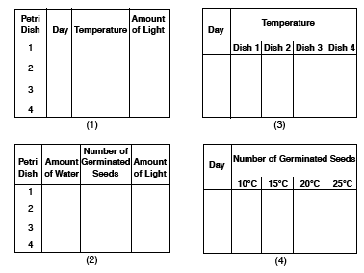

10. In an investigation to determine the change in heart rate with increased activity, a biology teacher asked students to take their pulses immediately before and immediately after exercising for 2 minutes. The data showed an average heart rate of 72 beats per minute before exercising and 90 beats per minute after exercising. If a valid conclusion is to be made from the results of this investigation, which assumption must be made?
(1) In most students, the average heart rate is not affected by exercise.
(2) Exercise causes the heart rate to slow down.
(3) Each student exercised with the same intensity.
(4) The heart rate of each student goes up 18 beats after jogging for 2 minutes.

11. An investigation was performed to determine the resistance of two species of Anopheles mosquito to the insecticides malathion and dieldrin. In May, two groups of 10,000 insects of each species were sprayed with insecticide. One group was sprayed with malathion, the second group with dieldrin. The number of surviving insects was recorded after the first spraying. The surviving insects were then allowed to reproduce. Several generations of new offspring were produced over the following three months. On the first day of each month they were sprayed, and the number of survivors was recorded in the table below.

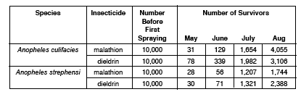
State one valid conclusion that can be drawn from these data.

12. You are the head of the research division of the Leafy Lettuce Company. Your company is experimenting with hydroponic technology. Hydroponic technology involves growing plants in containers of growth solution in a greenhouse. No soil is used. Your first experiment used five groups of five plants of the same size and species. Each group was grown in a different growth solution for the same period of time. The results of the experiment are shown in the table below.

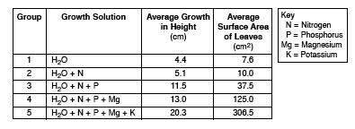
In your report to the president of the Leafy Lettuce Company you summarize the results of your experiment. On your answer sheet include the following information:

a) a recommendation of the best growth solution to use for hydroponic lettuce [Support your recommendation by explaining why]

b) another possible variable (besides the growth solution) that might be investigated to improve the growth of the hydroponic lettuce.

c) a recommendation to make these data more valid

d) Could the results of this investigation be used to select the best growth solution for other species of plants? Explain your answer.

13. In an experiment to test the effect of light on plant growth, a student used two marigold plants of the same age. The two plants were grown in separate pots. One pot was exposed to sunlight, the other to artificial light. All other conditions were kept the same. The height of each plant was measured at the start and at the end of the experiment. The student’s data are shown in the table below.
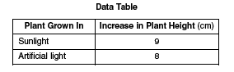
The student concluded that “all plants grow more rapidly in sunlight than in artificial light”.
Discuss whether this conclusion is valid by answering the following questions:

a) Explain the significance of the difference in the results shown in the data table

b) Explain the significance of the number of individual plants used in the experiment

c) Explain the significance of the number of species of plants used in the experiment

