Name: __________________________________________________________________Period: ______ Alpha#: ______
Food Web #1:
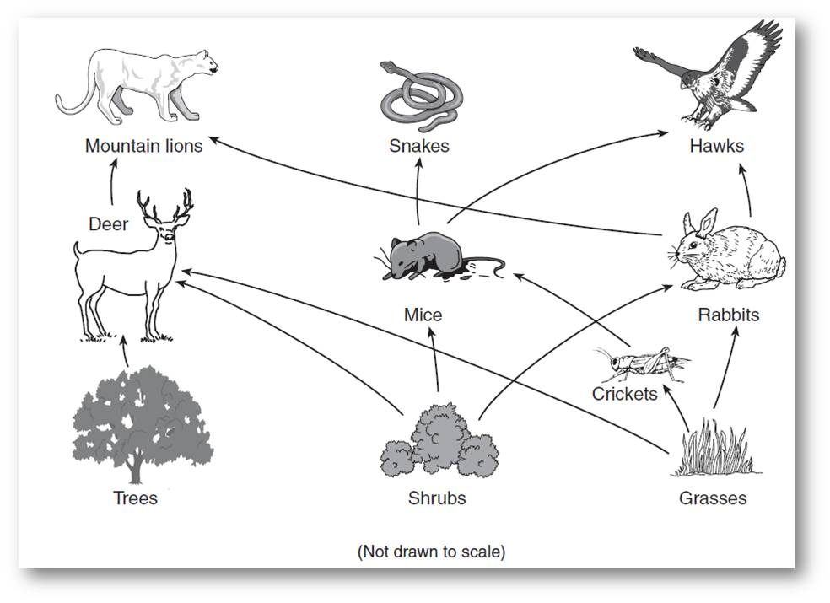
- ______Hawks are either:
- Producer B. primary consumer C. secondary consumer D. tertiary consumer
- ______How much biomass will a hawk assimilate from a rabbit if a rabbit has a biomass of 45lbs.
- 450lbs B. 4500lbs C. 4.5lbs D. .45lbs
- ______What organisms are on trophic level three?
  - Mountain lion B. snake C. deer D. hawk
- ______ By what process do producers make their biomass (glucose) from solar energy?
  - Cellular respiration C. photosynthesis
  - Assimilation D. Biomass
- ______Which of the following is a top predator?
  - Rabbit B. hawk C. cricket D. grass
- ______ If a tree contained 1,000,000 cal of biomass then how many calories would be passed up to the
mountain lion from a tree?
  - 100,000 B. 10 C. 10,000 D. 100
- ______ How much energy is passed on to the next level in a food chain?
  - 5% B. 10% C. 50% D. 100%
- ______Which organism is NOT a secondary consumer in one of the food chains above?
  - Snake B. hawk C. mouse D. cricket
- ______ What kind of consumer is a hawk?
  - Carnivore B. omnivore C. herbivore D. producer
- ______ What trophic level is the mountain lion on?
  - 1 B. 2 C. 3 D. 4
- ______ If a mountain lion needs 1500lbs of deer biomass per year, how much tree biomass does the
deer need ?
  - 150 B. 300 C. 1.5 D. 15000
- ______ Trees, grasses, and shrubs are
  - Producers B. heterotrophs C. autotrophs D. A and C
- ______ How does biomass travel up the food chain or through a food web?
  - Cellular respiration C. photosynthesis
  - Assimilation D. Biomass
- ______ What happens to the 90% of the energy that is not passed up a food chain?
  - It is used for metabolism or lost as heat C. It is stored as biomass for the next level
  - It is passed down the food chain D. It is used for photosynthesis

In the food chain: grain mice raccoon wolf
- If there are 25,000 lbs of grain, draw a pyramid of biomass for the food chain
- Using the pyramid of biomass above:
  - If raccoons weigh 50lbs how many are there in this food chain? ____________________
  - If the raccoons could not eat any mice how many lbs of grain ____________________
would they need in one year?
- If there are 50,000 calories at trophic level 2, draw a pyramid of energy for the food chain above

