Name: _____________________________________________________________________ Period: _____ Alpha #: _____

|  |  |
| --- | --- |
|  |  |
|  |  |

**Punnets and Pedigrees Review**

**Mendelian one trait crosses:**

1. **______In mice black fur is dominant to brown fur. What are the possible genotypes of a cross between a heterozygous mouse and a homozygous recessive mouse?**
   1. BB and bb C. Bb and bb

|  |  |
| --- | --- |
|  |  |
|  |  |

* 1. BB and Bb D. Bb, Bb, and bb

1. **______When a blue and white flower are crossed all of the flowers are blue. Cross a homozygous blue flower with a heterozygous blue flower. How many of the flowers will be blue?**
   1. 50% B. 25% C. 100% D. 0

|  |  |
| --- | --- |
|  |  |
|  |  |

1. **______ Right handedness is dominant to left handedness. If a right handed man with a left**

**handed mother marries a woman who is heterozygous, what fraction of their children is predicted to be left handed?**

* 1. 50% B. 25% C. 100% D. 0

|  |  |
| --- | --- |
|  |  |
|  |  |

1. **______A homozygous recessive albino rat is mated with a heterozygous normal rat.   
   What are the possible phenotypes of the offspring in the correct ratio?**
   1. All normal C. 75% normal, 25% albino
   2. 50% normal, 50% albino D. All albino
2. **Blue eyes(E) are dominant to purple eyes(e) in the aliens of Altair II. Cross a purple eyed**

|  |  |
| --- | --- |
|  |  |
|  |  |

**male with a heterozygous blue eyed female. Fill in the expected percentage probability  
of the following genotypes:**

Homozygous dominant: ______homozygous recessive:______ heterozygous: ______

1. **Green (G) is dominant to yellow (g) in fish. List the cross, genotypes, genotypic ratio, phenotypes, and phenotypic ratio of a cross between two heterozygous green fish.**

|  |  |
| --- | --- |
|  |  |
|  |  |

cross: ________________________________

genotypes: ___________________________ genotypic ratio: _________

phenotypes: ____________________________________ phenotypic ratio: _________

**Mendelian two trait crosses:**

1. **______ What is the phenotypic ratio of a dihybrid (both parents heterozygous for two traits) cross:**
   1. 3:1 B. 9:3:3:1 C. 1:2:1 D. 1:3:3:9
2. **In a dihybrid cross AaBb x AaBb, offspring can have both dominant phenotypes *A and B*, both recessive phenotypes *a and b*, or one dominant and one recessive A *and b* or *a and B*.**
   1. Which numbers in the expected ratio of 9:3:3:1 match with these phenotypes?

______ A and B ______ a and b ______ A and b ______ a and B

* 1. If there were 32 offspring instead of 16, how many would have the a and b phenotype? ______

1. **______All of the following are possible genotypes for the cross aabb x AaBb EXCEPT** 
   1. AaBb B. aabb C. AAbb D. Aabb
2. **Yellow eyes (E) in cats are dominant to green eyes (e). Long tails (T) is dominant to short tails (t). Cross a heterozygous yellow eyed, homozygous long tailed cat with a green eyed, heterozygous long tailed cat. List the cross and the possible genotypes with their corresponding genotypes for this cross. The write the genotypic and phenotypic ratio.**

|  |  |  |  |
| --- | --- | --- | --- |
|  |  |  |  |
|  |  |  |  |
|  |  |  |  |
|  |  |  |  |

cross: ______________________________  
  
 genotypes: phenotypes:

Genotypic ratio: _________ phenotypic ratio: _________

|  |  |  |  |
| --- | --- | --- | --- |
|  |  |  |  |
|  |  |  |  |
|  |  |  |  |
|  |  |  |  |

1. **In mice white fur (F) is dominant to brown fur (f) and black eyes(B) are dominant to pink eyes(b). Cross two mice that are heterozygous for fur color and eye color. List the cross along and the expected fraction of each possible phenotype.**cross: ___________________________

|  |  |
| --- | --- |
|  |  |
|  |  |

Phenotype: Expected fraction:

**Non Mendelian Crosses:**

1. **______ A human female who is heterozygous for the recessive, X-linked trait causing**

**red-green color blindness marries a normal male. What proportion of their male progeny   
will have red-green color blindness**

|  |  |
| --- | --- |
|  |  |
|  |  |

* 1. 50% B. 25% C. 100% D. 0

1. **______ In some dog breeds white is codominate with black. A heterozygous dog that**

**has a mix of white and black hairs is called a brindle. If two brindle dogs are crossed what  
is the expected phenotypic ratio of the offspring?**

* 1. 3:1 B. 1:2:1 C. 9:3:3:1 D. 1:1

|  |  |
| --- | --- |
|  |  |
|  |  |

1. **______ A woman who is homozygous for type A blood married a man with type AB blood. What are the expected blood types for their offspring?** 
   1. A and B B. only AB C. A, AB, and B D. A and AB
2. **______When blue flowers are crossed with yellow flowers they make green flowers. If a green flower is crossed with a blue flower, what fraction of the flowers would be yellow?**

|  |  |
| --- | --- |
|  |  |
|  |  |

* 1. 3/4 B. 2/4 C. 1/4 D. 0/4

|  |  |
| --- | --- |
|  |  |
|  |  |

1. **In birds, yellow eyes are a X-linked recessive trait to black eyes. If a yellow eyed male is crossed with a black eyed heterozygous female, what would be the cross, phenotypes, and genotypes of the expected offspring?**Cross:_____________________________________

genotypes: phenotypes:

|  |  |
| --- | --- |
|  |  |
|  |  |

1. **White fur is incompletely dominant to black fur in mice. Cross two grey mice and list the cross and expected genotypes in the correct ratios.**cross:_____________________________________

genotypes: phenotypes:

1. **A woman with type O blood married a man with type A blood whose father had type O. What would be the cross and the expected genotypes and phenotypes of the possible offspring?**

cross:_____________________________________

|  |  |
| --- | --- |
|  |  |
|  |  |

genotypes: phenotypes:

1. **In cows white and red fur are codominant. A heterozygous cow is called roan. Cross a red and a roan cow. What would be the cross and the expected genotypes and phenotypes of the possible offspring?**

|  |  |
| --- | --- |
|  |  |
|  |  |

cross:_____________________________________

genotypes: phenotypes:

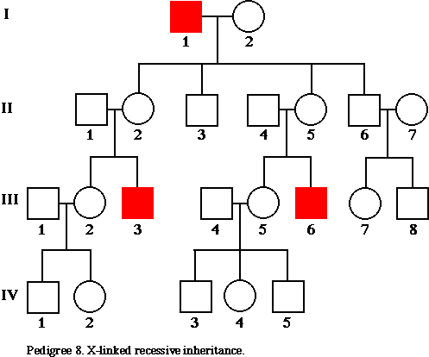**Pedigrees**

**For the next 4 questions use the pedigree to the right.**

1. **______What type of pedigree is this?** 
   1. Autosomal dominant
   2. Autosomal recessive
   3. X-linked recessive
2. **______ What is the genotype of individual III, 3?**
   1. XaY C. XAY
   2. Aa D. aa
3. **______ What is the genotype of individual II,5?**
   1. aa C. Aa
   2. XAXa  D. XaXa
4. **______ What is the genotype of individual IV,1?**
   1. XaY C. XAY
   2. Aa D. aa

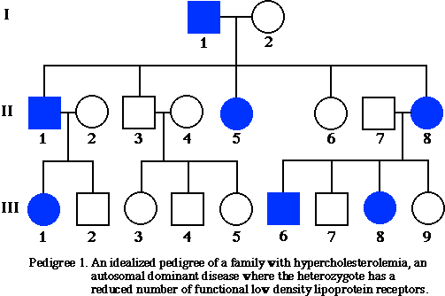**For the next 5 questions use the pedigree to the right**

1. **______What type of pedigree is this?** 
   1. Autosomal dominant
   2. Autosomal recessive
   3. X-linked recessive
2. **______ What is the genotype of individual II,8?**
   1. Aa B. aa C. XaXa
3. **______ What is the genotype of individual II,4?**
   1. XAXa  B. aa C. Aa
4. **______ What is the genotype of individual I,1?**
   1. XAY B. aa C. Aa
5. **______ What was the probability that individual III, 1  
    would be Aa?**
   1. 0 C. 1/2
   2. 1/4 D. 3/4

**For the next 5 questions use the pedigree to the right**

1. **______What type of pedigree is this?**
2. Autosomal dominant
3. Autosomal recessive
4. X-linked recessive
5. **______ What is the genotype of individual III,4?**
   1. AA C. aa
   2. XaY D. cannot determine
6. **______ What is the genotype of individual II,4?**
   1. XAXa  C. aa
   2. Aa D. cannot determine
7. **______ What is the percent probability that individual   
    III,2 is Aa?**
   1. 25% C. 50%
   2. 100% D. 0
8. ______  **What is the percent probability that individual   
    III,3 is aa?**
   1. 25% C. 50%
   2. 0% D. 75%

**Challenge:**

1. **In humans left-handedness is recessive to right-handedness. A right handed woman whose mother was left handed with type O blood marries a heterozygous right handed man with type B blood whose mother had type O**.   
   1. Cross: __________________________

|  |  |  |  |
| --- | --- | --- | --- |
|  |  |  |  |
|  |  |  |  |
|  |  |  |  |
|  |  |  |  |

* 1. What percent of the offspring will have   
     the same genotype as their father?
  2. What are the possible blood types for   
     the children of this marriage?
  3. What are the genotypes and corresponding  
      phenotypes for the children of this marriage?  
       
     Genotypes: Phenotypes:

1. **In mice pink eyes are a X - linked recessive to black eyes and black fur is codominant with white fur. Cross a female pink eyed, speckled fur mouse with a male black eyed, black furred mouse.**
2. Write the cross: __________________________

|  |  |  |  |
| --- | --- | --- | --- |
|  |  |  |  |
|  |  |  |  |
|  |  |  |  |
|  |  |  |  |

1. What percent of the male offspring   
   will be black, pink eyed mice?

1. What is the percent probability of   
   pink eyed, speckled mice?
2. What color eyes must all the female   
   mice have?