Hon POD #11

Monday #1: When we say we eat food (glucose) to as fuel we cant actually use glucose. What do we do with the energy in glucose so we can use it?
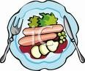

Tuesday #2. The energy stored in food is measured in calories. Where are the calories stored in food?

Wednesday #3. When you “burn” food the weight of the food decreases. Where does the mass go?

Thursday #4. THANKSGIVING

Friday #5. THANKSGIVING

