Honors POD #23

Monday #1: What is the overall result of Mitosis?

Tuesday #2: If a cell has 4 chromosomes how many does each new cell have after Mitosis? After Meiosis?
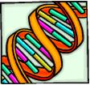

Wednesday #3: : How many copies of each chromosome are there in gametes?
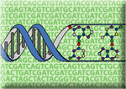

Thursday #4: You have 100 trillion cells in your body. How many X chromosomes do YOU have?

Friday #5: Define “Diploid”
