Pre-Lab Questions

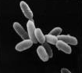

- What question are you investigating?
- What is the manipulated variable in this experiment?
- If we see an effect, what do you think the responding variable will be?
- Name two controlled variables in this experiment.
- What is your hypothesis for this experiment?
- What do you predict will happen in this experiment?

