Name: ____________________________________________________Period: ______

Introduction to Macromolecules Answer Sheet

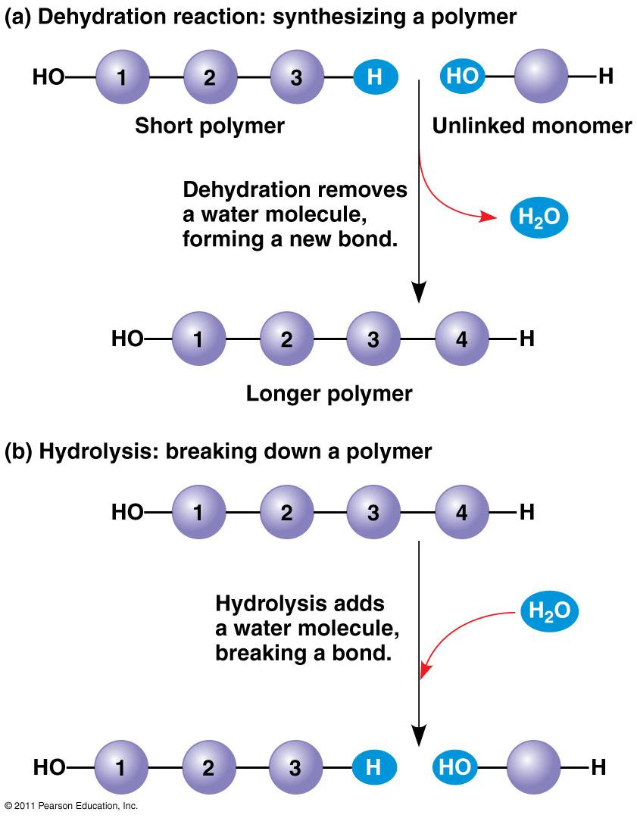
Biological Macromolecules:
Most common elements in living things are carbon, hydrogen, nitrogen, and oxygen. These four elements constitute about 95% of your body weight. All compounds can be classified in two broad categories --- organic and inorganic compounds. Organic compounds are all based on carbon. Carbon can form single bonds with another atom and also bond to other carbon molecules forming double and triple bonds. This allows carbon based molecules to form single and double rings, chains, and branching chains. Most organic compounds are built primarily of carbon, hydrogen, and oxygen but in different ratios. Each small organic molecule can be a unit of a large organic molecule called a macromolecule. If the small organic units are identical or form patterns they are called monomers and the large organic molecule they form is called a polymer.
When monomers are joined together the reaction is called dehydration synthesis or condensation as water is produced when the monomers are bonded together. To break the polymers down again the reaction is called hydrolysis. Notice how water is used or produced in these two reactions shown to the right
There are four classes of macromolecules: carbohydrates, lipids, proteins, and nucleic acids. Heterotrophs, like us, must get these biological macromolecules from our food which we break down into monomers through digestion. This makes the molecules small enough to cross cell membranes. Our cells use them either as energy sources or to build the carbohydrates, proteins, lipids, and nucleic acids that our body needs.

Questions:
- What atom makes up the backbone of biological macromolecules?
Carbon

What kinds of shapes can carbon based molecules form:

single and double rings, chains, and branching chains.

What are macromolecules?
a large organic molecule
- How are monomers related to polymers?
If the small organic units are identical or form patterns they are called monomers and the large organic molecule they form is called a polymer

When polymers are built, the process is called a dehydration reaction. Why is the word “dehydration used?”

Water is removed to form the bond between monomers
- Organisms not only build molecules, they also break them down. This chemical reaction is
called Hydrolysis
- What does the prefix “hydro” and the suffix “lysis” mean?
Water and Splitting
- Why does a cell (or your body) need to break down polymers into monomers? Give at least two reasons for this….
This makes the molecules small enough to cross cell membranes. Energy
- Life’s large molecules or “polymers” are classified into what four categories?
Carbs, Lipids, Proteins, and Nucleic acids
Carbohydrates:

Carbohydrates are sugars, starches, and glycogen which are used for short and long term energy storage in cells and structural molecules in cell walls and exoskeletons. Carbohydrates are made of only carbon, hydrogen, and oxygen (CHO). They are found in bread, potatoes, pasta, and fruits.
Carbohydrates are made of smaller subunits (monomers) called monosaccharides. Monosaccharides or simple sugars include glucose, galactose, and fructose. Glucose comes from photosynthesis and is converted into either galactose or fructose by plants. Two simple sugars combine to make disaccharides (double sugars like lactose – milk sugar and sucrose – table sugar) and more than two monosaccharides make polysaccharides (cellulose, chitin, starch, and glycogen).
Plants store glucose as starch which is simply long chains of glucose with a few side branches. Animals store glucose as glycogen which is those same long chins but more heavily branched. Cellulose makes up plant cell walls and is three chains of glucose twined together like rope attached with hydrogen bonds. Chitin, which makes up the exoskeleton on insects and crustaceans, is a long chain of glucose with one amino acid attached to each one.
Questions:

What are the subunits called that make up carbohydrates? Monosaccharide
- What are the two functions of carbohydrates in living organisms?

Energy storage, Structural

- In the list below circle the polysaccharide(s), underline the disaccharide(s), and put a star next to the monosaccharide(s).

Cellulose glucose * fructose* starch sucrose

glycogen galactose* maltose lactose

- What monomers make up the following:

  - Sucrose Glucose/fructose

  - Maltose Glucose/Glucose
  - Lactose Glucose/Galactose

- Describe the structure of the following carbohydrates:
  - Starch simply long chains of glucose with a few side branches
  - Glycogen same long chins but more heavily branched
  - Cellulose three chains of glucose twined together like rope attached with hydrogen bonds
- What is the function of the energy storing polysaccharides starch and glycogen?
short and long term energy storage
- What is the function of the two structural polysaccharides (c&d)?

makes up the exoskeleton on insects and crustaceans

Lipids:
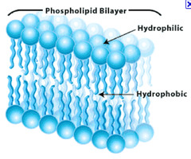
Lipids are used for cell membranes, long term energy storage, and insulation. Lipids are large, nonpolar (won't dissolve in water) molecules. Lipids serve as waxy coverings on plant leaves to prevent dehydration and on the feathers of aquatic birds to keep them dry in the water. Lipids can also be pigments (chlorophyll), hormones (estrogen, testosterone, adrenaline), and sterols (cholesterol).
Fats and oils are made of a glycerol and three fatty acid chains. This is sometimes called a triglyceride. The fatty acid chains are saturated (only single bonds between carbons) in fats and unsaturated (contain at least one double bond) in oils.
A special type of lipid called a phospholipid make up the cell membrane. Instead of three fatty acids and a glycerol one of the fatty acids is replaced by a phosphate group. This makes the phospholipid molecule polar at one end and nonpolar at the other. Phospholipids have a hydrophilic (polar) head - the phosphate and two hydrophobic (nonpolar) tails – the fatty acids. In water they orient themselves in a bilayer with the phosphate facing towards the water the fatty acid tails facing each other.
Questions:
- What are the three functions of Lipids?
cell membranes, long term energy storage, and insulation
- What is the structural difference between a fat and an oil?
The fatty acid chains are saturated (only single bonds between carbons) in fats and unsaturated (contain at least one double bond) in oils.
- Why is wax useful as a barrier to water on the surfaces of plants and feathers?
Prevents dehydration
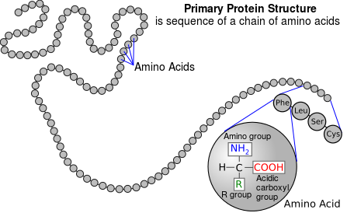
- Name the two parts of a phospholipid. Which part(s) are polar and which are nonpolar?
Phospholipids have a hydrophilic (polar) head - the phosphate and two hydrophobic (nonpolar) tails
Proteins:
Proteins make up the majority of the structure of plants and animals and act as enzymes to speed up chemical reactions. Proteins are made of subunits (monomers) called amino acids that determine the structure, shape, and function of the protein. The bonds between the amino acids are called peptide bonds and for this reason proteins are called polypeptides.
Each amino acid has the same structure except for a section called the R group. R stands for radical which mean that the structure varies. There are 20 different variations so there are 20 amino acids. Each amino acid has different properties that interact with each other when they are joined together in a protein. This is why shape and structure are so important to protein function. If the temperature or pH varies this can change how the amino acids interact and damage or denature (make nonfunctional) the protein. Proteins are made of carbon, hydrogen, oxygen, and nitrogen (CHON) and are found in meats, nuts, and some types of beans.

Questions:

What monomers make up proteins? Amino Acids
- What are the two functions of proteins: Structural, Enzymes

- What determines function in a protein? Its Shape

List and describe the function of 2 common proteins Keratin (Hair and Nails), Collagen (plumps skin),

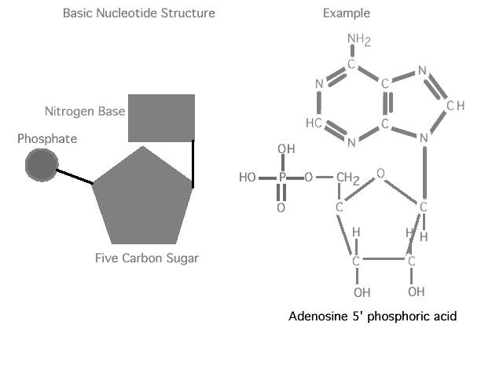
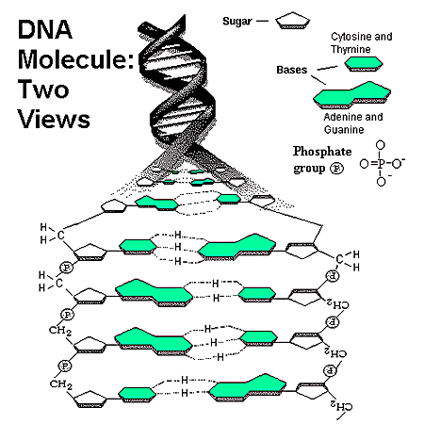
Nucleic Acids:
Nucleic acids are DNA (deoxyribonucleic acid) and RNA (ribonucleic acid). DNA and RNA contain carbon, hydrogen, oxygen, nitrogen, and phosphorus (CHON P). Nucleic acids carry the genetic information in a cell. DNA or deoxyribose nucleic acid contains all the instructions for making every protein needed by a living thing. RNA copies and transfers this genetic information so that proteins can be made. The monomers that make up nucleic acids are called nucleotides.
Nucleotides are made of a phosphate group attached to a pentose (5 carbon) sugar and a nitrogenous (contains lots of Nitrogen atoms) base. In DNA the sugar is deoxyribose and the N-bases are adenine, guanine, cytosine, and thymine. The N-bases are usually abbreviated by just their first letter – AGCT. DNA is two strands of nucleotides attached in the middle by hydrogen bonds. RNA has ribose as its sugar and the same AGC N-bases as DNA but the T is swapped for U (urasil). RNA is a single strand of nucleotides.

Questions:
- Name the two nucleic acids and give the general function of each.
DNA and RNA. Store information to run the cell

- What is the monomer of nucleic acids? Nucleotide
- What are the three parts of this monomer? DeoxyRiboseSugar/Phosphate/Nitrogen Base

