Honors POD #22

Mon. #1: Wed #3: What is metabolism and how do you think it is controlled inside of a cell?
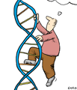

Tues. #2: What does transcription do?
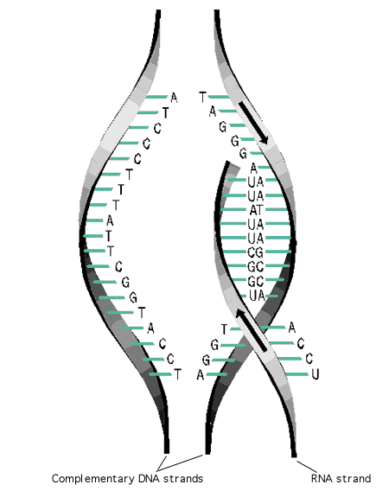

Wed. #3: Why is a point mutation in a gene less damaging to the protein than an insertion or deletion mutation?
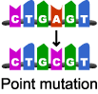

Thurs. #4: How does RNA Polymerase know where to start and stop transcribing a gene?
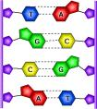

Fri. #5: PROTEIN SYNTHESIS TEST

