Hon POD #27

Mon. #1: What, if any, is the disadvantage to altering the genetic makeup of your offspring?
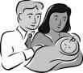

Tues. #2: What is the biggest risk factor for having a child with Trisomy 21?

Wed. #3: Tom has blue eyes (a recessive trait) and Deb was heterozygous for brown eyes. What will you tell them their chances are of having a blue eyed child?
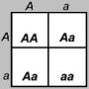

Thurs. #4: What is the term given to the mistake during Meiosis when both homologous chromosomes are pulled into the same cell?

Fri. #5: In Rabbits, long ears are dominant (E) over short ears (e) If a long-eared male and short-eared female have no short eared offspring what was the genotype of the father.
