Name: __________________________________________________________________Period: _____

**DNA Transcription & Translation Worksheet**

1. **Identify the processes and products in the diagram**
   1. Process 1 is known as: ________________________________

DNA

RNA

DNA

Protein

1

2

3

* 1. Process 2 is known as: ________________________________
  2. Process 3 is known as: ________________________________

**Fill in the blank:** (Use your T&T vocab WS or notes to complete the following)

1. **The process of making the mRNA using the DNA is called: ________________________ and takes place in the ________________________.**
   1. ________________________ and ________________________bind to the promotor region of the ________________________ to turn it ‘on’. This is called: **________________________**.
   2. RNA polymerase makes a **________________________**copy of the **________________________**DNA strand.
   3. When RNA polymerase gets to the ________________________region of the gene it detaches along with the _**_______________________**. This is called: **________________________**

1. **The process of making the protein from mRNA is called: ________________________. This takes place in the ________________________ at the ________________________.**
   1. The ribosome attaches to the ________________________. The ______ binds to the ________________________codon matching mRNA codon to ________________________.
   2. The next correct ______ enters the ribosome. This is checked by matching the complementary tRNA _______________________ to the mRNA _______________________ . The ________________________ from the first (oldest) tRNA is transferred and bonded to the ________________________ of the second (newest) ______. This repeats until a _______________________is read by the ribosome.
   3. The mRNA _______________________ binds to a_______________________ factor and the _______________________, _______________________ , and _______________________ all come apart. The _______________________ then folds into its finished shape.

4 – Location in cell

2 – Location in cell

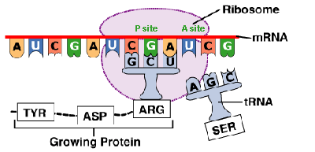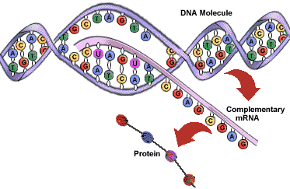

111

8

10

9

12

5 - Process

3 - Process

12

6

1

7

1. **Identify the parts of transcription and translation in the diagram above:**  
   ______ ribosome ______ codon ______anticodon ______tRNA

______ transcription ______ nucleus ______ cytoplasm ______ DNA

______ translation ______ mRNA ______ amino acid ______ new protein

|  |  |  |  |  |  |  |  |  |
| --- | --- | --- | --- | --- | --- | --- | --- | --- |
|  |  |  |  |  |  |  |  |  |

1. **Fill in the missing nucleotides on the DNA and then convert it to mRNA, tRNA, and the corresponding amino acids. Use the bottom strand as a template.**

tRNA

DNA

|  |  |  |  |  |  |  |  |  |
| --- | --- | --- | --- | --- | --- | --- | --- | --- |
| **T** |  |  | **G** | **T** | **C** | **A** |  | **T** |
|  | **T** | **G** |  |  |  |  | **A** |  |

|  |  |  |  |  |  |  |  |  |
| --- | --- | --- | --- | --- | --- | --- | --- | --- |
|  |  |  |  |  |  |  |  |  |

AA

mRNA

1. **Name the type of mutation: (substitution, insertion, or deletion) and its effect(s): (frameshift, silent, missense, or nonsense) on the following:**

**normal:** TACGGGAATTGGAGAACT

* 1. TACGAGAATTGGAGAACT
  2. TACGGGAATTGGAGAAAACT
  3. TACGGGATTGGAGAACT

**type: effect(s):**

1. **_______________________________ A. _____________________________________**
2. **_______________________________ B. ______________________________________**
3. **_______________________________ C. ______________________________________**