The Ultimate Biology Review
2nd Semester
Evolution

Evidence for Evolution: Fossil lineages, Anatomical similarities, and molecular homology.

- Fossils are one line of evidence that species have changed over time.
- Scientists use anatomical similarities to create cladograms to study evolutionary relatedness.
- Molecular evolution:In the past Classification was mostly based on anatomy (what a species looks like). Now we can classify species based on DNA similarity (genes, the code that determines the shape of proteins and therefore your inherited characteristics) and how closely related species are genetically.

Homologous & Analogous Biological Structures:
- A homologous structure is an organ, system, or body part that shares a common ancestry in multiple organisms. This definition is found in evolutionary biology, and uses the meaning of having a similar structure or origin.
  - Homologous structures look similar but have different functions.
- Analogy, in biology, similarity of function and superficial resemblance of structures that have different origins. For example, the wings of a fly, a moth, and a bird are analogous because they developed independently as adaptations to a common function—flying.
  - Analogous structures have the same function but appear different anatomically.

Vestigial Structures: These are organs that have lost their function and are reduced in size. An example is the appendix.

- Refer to EVOLUTION packet
  - Evolution Review Packet Answer Key
  - 1. a.
2. d.
3. a
4. c.
5. b.
6. d.
7. a
8. d.
9. a.
10. d.
11. b.
12. c.
13. c.
14. c.
15. d.

History of the Earth

13.7 Billion years : Age of Universe
4.7 Billions years : Age of Earth
3.5 Billion years : Age of Bacteria
1.5-2 Billion years : Age of Algae
600 Million years : Complex Multicellular Life
2 Million years : Humans

To Classify: Kingdom, Phylum, Class, Order, Family, Genus, Species

Calculating Half-Life: An isotope has a half life of 25 years. How many years for 0.024 grams of fully radioactive material to decay to 0.006g of radioactive material? 50 years.

Absolute & Relative Time:
- Absolute time is the measurement taken from the same rocks to determine the amount of time that has expired.
- Relative time is the physical subdivision of the rocks found in the Earth's geology and the time and order of events they represent.

Cladograms Illustrate:
- Shared traits and characteristics
- How groups of organisms are related
- A common ancestor

How Scientists Date Rocks:
- Measuring the radioactivity and the percentage of radioactive atoms remaining according to half lives.
- Looking at the dates of the rocks below and above.

Why We Can’t Use C14 to Date Fossils: The half life of C14 is 5600 years. The C14 will be undetectable because the half life is too small. Fossil eventually becomes rock.

Genetics and Heredity

Genetics and Heredity: Organisms inherit genetic material from their parents in the form of homologous chromosomes, containing a unique combination of DNA sequences that code for genes.

Monohybrid Punnett Square: A monohybrid punnett square is used to predict the likelihood of one trait.

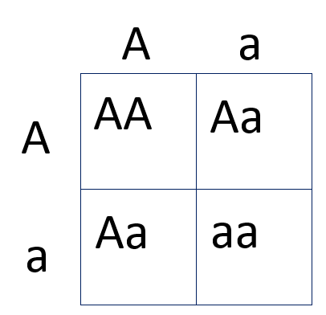
Dihybrid Punnett Square: A dihybrid punnett square is used to predict the likelihood of a two trait combination.

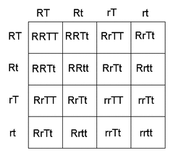

Sex-linked Traits: A trait associated with a gene that is carried only by the male or female parent. Note : In humans, the gene for colorblindness is carried by the X-chromosome.

Alleles: Alleles are variations of a gene located in chromosomes. Code for traits such as eye color.

Pedigrees: A pedigree is like a “genetic family tree” used to track traits passed down from generation to generation.

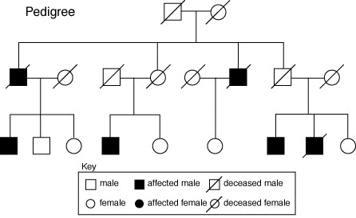

Mitosis and Meiosis

Goal of Mitosis: to produce two daughter cells that are genetically identical to the parent cell, meaning the new cells have exactly the same DNA as the parent cell. One diploid cell → two diploid cells.

Goal of Meiosis: to produce sperm or eggs, also known as gametes. Goal is genetic shuffling and production of gametes. One diploid cell → four haploid cells.

How Mitosis & Meiosis Differ:
- Meiosis has two rounds of genetic separation and cellular division while mitosis only has one of each.
- Meiosis includes two nuclear divisions. The four daughter cells resulting from meiosis are haploid and genetically distinct.
- The daughter cells resulting from mitosis are diploid and identical to the parent cell.

Cell Cycle: The primary purpose of cell division is to replicate each parent cell (by dividing into two cells) while maintaining the original cell's genome. The cell cycle can be separated into two major phases that alternate with each other: interphase, during which the cell grows, prepares for mitosis and duplicates its DNA, and the mitotic (M) phase, in which the cell divides into two genetically identical daughter cells.

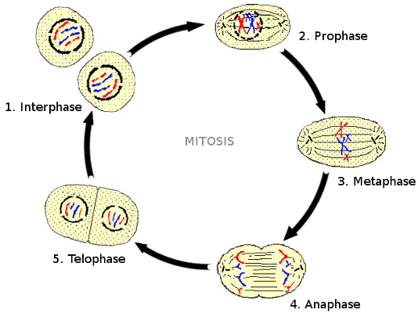

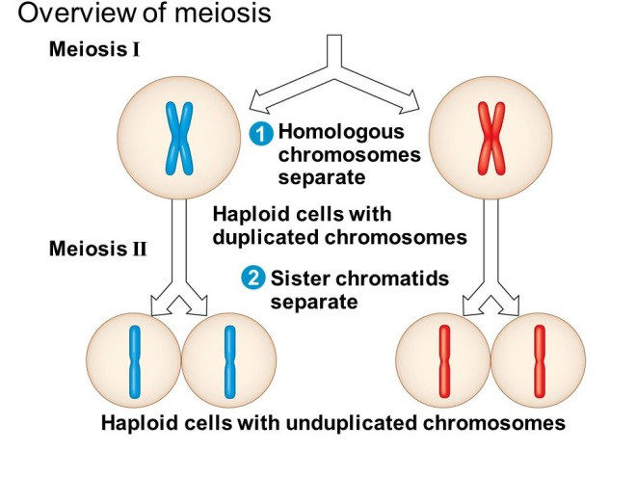
Crossing Over: (genetic recombination) is the process where homologous chromosomes pair up with each other and exchange different segments of genetic material to form recombinant chromosomes. It occurs between prophase 1 and metaphase 1 of meiosis. This generates variation.

Semester 2 Final
Vocabulary

Meiosis (Meiosis I, Meiosis II) part of the process of sex cell formation, consisting of chromosome pairing and two cell divisions, in the course of which the diploid chromosome number becomes reduced to the haploid
Diploid: an organism or cell having double the basic number of chromosomes.
Haploid: an organism or cell having only one complete set of chromosomes, ordinarily half the normal diploid number
Gamete (Sperm, Egg): a mature sexual reproductive cell
Zygote: the cell produced by the union of two gametes, before it undergoes cell division.
Homologous chromosomes: having the same alleles or genes in the same order of arrangement:
Crossing over: the interchange of corresponding chromatid segments of homologous chromosomes with their linked genes.
Alleles: A pair of alternative forms of a gene that occupy the same locus on homologous chromosomes and that control the production of the same protein.
Dominant: Some alleles are dominant over others and produce a phenotype regardless of the other allele
Recessive: Some alleles are recessive over others and produce a phenotype only in the presence of the other allele
Genotype: The genetic makeup of an organism (the alleles that an organism contains on its chromosomes).
Phenotype: The outward appearance and behavior of an organism.
Homozygous: Having the same alleles at a particular gene locus on homologous chromosomes.
Heterozygous: Having different alleles at a particular gene locus on homologous chromosomes.
Scientific Fact: a truth known by actual experience or observation; something known to be true and verifiable by others.

Hypothesis: A prediction and an explanation for the occurrence of an observation.
Scientific Theory: A set of principles used to explain a group of facts. It has been repeatedly tested and is widely accepted. A theory can be used to make predictions about the natural world.

Scientific Law: A phenomenon of nature that has been proven to invariably occur whenever certain conditions exist or are met.
Belief: A personal mental attitude of acceptance of a proposition without any evidence to guarantee its truth.
Geology: The scientific study of the origin, history, and structure of the solid matter of The Earth
Geological time: the relative age of various geologic periods and the absolute time intervals as measured in Millions and Billions of years
Sedimentary rock: A rock formed by hardened sediment which was deposited in layers at the bottom of a sea or lake.
Plate Tectonics: The dynamics of continental plate movement on the Earth
Sequential (or Relative) time: Time determined by the placing of events in a chronologic order of occurrence relative to each other
Absolute time: the actual time (usually measured in years) as determined by radioactive decay of elements.
Isotope: any of two or more forms of a chemical element, having the same number of protons in the nucleus but having different numbers of neutrons in the nucleus
Half Life: the time required for one half the atoms of a given amount of a radioactive substance to disintegrate
Radioactive decay: Spontaneous disintegration of a radionuclide accompanied by the emission of ionizing radiation in the form of alpha or beta particles or gamma ray
Natural Selection: Differential reproductive success of phenotypes resulting from interaction with the natural environment.
Phylogeny: The evolutionary history of a species.
Biodiversity: Number and relative abundance of species in a biological community. Example: Seven species of grass plants in the same prairie.
Species: A group of individuals with similar anatomical characteristics and capable of interbreeding to produce fertile offspring.
Variation: Differences in characteristics among individual species.
Adaptation: Any alteration of structure, behavior, or function that makes an organism more reproductively successful.
Extinction: Coming to an end or dying out of a species.
Biological Evolution: Changes in life forms over time.
Speciation: The evidence of new species evolving.
Artificial Selection: Human intervention in animal or plant reproduction to select for certain desirable traits.
Cladogram: a branching diagram depicting the successive points of species divergence from common ancestral lines
Body organ system: A group of related organs and tissues whose goal is to perform a specific function.
Organ: is a group of tissues that perform a specific function or group of functions.
Tissue: a group of similar cells and cell products forming a definite kind of structural material with a specific function within a multicellular organism
Cell: a usually microscopic structure containing nuclear and cytoplasmic material enclosed by a semipermeable membrane and, in plants, a cell wall; it is the basic structural unit of all organisms

Homeostasis: the tendency toward a relatively stable equilibrium between interdependent elements, especially as maintained by physiological processes.

Organism: An individual living thing that can react to stimuli, reproduce, grow, and maintain homeostasis. It can be a virus, bacterium, protist, fungus, plant or an animal.

