Honors POD #6

Monday #1: What are the 5 main subheadings needed in your Halobacterium lab following the Title?

Tuesday #2. List two sources of error that may account for your 3 OD data points being different.
Wednesday #3 What sections are included in the conclusion of a scientific write-up?
Thursday #3. What part of the experiment comes in the form of graphs, tables, charts and written observations?
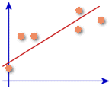
Friday #4. How are ecological chains and pyramids different?
