Honors POD #28

Mon. #1: Explain how a parent might have a trait disappear in their offspring and reappear in their grandchildren?

Tues. #2: What kind of cross results in a phenotypic ratio of 9:3:3:1 ?

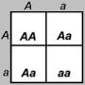

Wed. #3: Brown hair allele is dominant (B) & Blond hair allele is recessive (b)

A) If two brown haired parents have a blond child, give the genotype of the child and of the parents. (Show the Punnet square)

B) What is the chance of blonde parents having a brown-haired child?
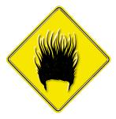

Thurs. #4: Write your own dyhybrid cross question.

Fri. #5: Genetics Test

