Honors POD #10

Monday #1. Veterans Day

Tuesday #2. Why do heterotrophs need autotrophs? And hand in your Vocab 2 (Photosynthesis)
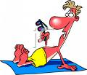

Wednesday #3. Oxygen gas is an output of “The Light Reaction”. Where do the oxygen atoms originate from?

Thursday #4. Give one input and one output for cellular respiration (Hint: it’s the opposite of photosynthesis).

Friday #5. At night time (no light) what molecules does the plant stop using?

